ACADEMIC MOBILITY REPORT
LEND (19.09.2014-23.01.2015)

Ainagul Birzhanova
1st year resident of endocrinology

Almaty, 2015
First of all I want to thank RektorAkanov A.A. and administration of the Kazakh National Medical University for providing me with such a magnificent opportunity for studying in USA in LEND program.
At the beginning I want to mention that the Maternal and Child Health Bureau of the US Department of Health and Human Services through the 2006 Combating Autism Act provides funding for Leadership Education in Neurodevelopmental and Related Disabilities (LEND) Programs. LEND Programs operate within a university system, usually as part of a University Center for Excellence on Developmental Disabilities (UCEDD) or other large entity, and collaborate with local university hospitals and/or health care centers. These collaborations provide the expert faculty, facilities, and other resources necessary to offer exceptional interdisciplinary training and services.
There are currently 39 LENDs in 32 states and the District of Columbia. Collectively, they form a national network that shares information and resources and maximizes their impact. While each LEND program is unique, with its own focus and expertise, they all provide interdisciplinary training, have faculty and trainees in a wide range of disciplines, including parents or family members and share the same learning objectives.
The Leadership Education in Neurodevelopmental and Related Disabilities (LEND) program at the Institute for Community Inclusion at Children's Hospital Boston provides advanced interdisciplinary training to health and counseling professionals and to families to improve their knowledge in working with children, adolescents and young adults with developmental and related disabilities. This training is multi-focused and ranges from policy issues and team collaboration to specific clinical practice and support models. Trainees develop their leadership potential to improve the status of infants, children, and adolescents with (or at risk for) neurodevelopmental disabilities and to enhance systems of care for these children and their families.
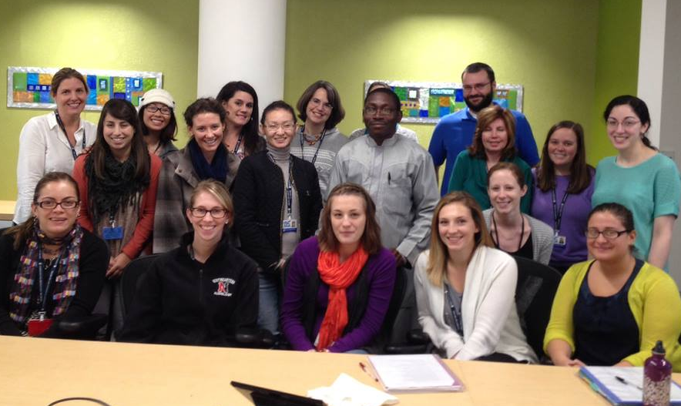
The program is appropriate for students in any professional discipline who work with children with developmental disabilities and their families, including but not exclusive to audiology, creative arts, dentistry, education, family medicine, health administration, law, nursing, nutrition, occupational therapy, pastoral counseling, pediatrics, physical therapy, psychiatry, psychology, public health, rehabilitation counseling, social work, and speech therapy. Family members who wish to advance their knowledge in these areas and who are working toward leadership roles in the field of maternal and child health are encouraged to apply and become a fellow as well.
Through LEND program I advanced the knowledge and skills to improve health care delivery systems for children with developmental disabilities. This program also provided high-quality interdisciplinary education to health and allied professionals that emphasized the integration of services supported by state, local agencies, organizations, private providers and communities; provided a wide range of professionals and families with the skills needed to foster a community-based partnership of health resources and community leadership; and promoted innovative practice models that enhance cultural competency, partnerships among disciplines, and family-centered approaches to care.
During my education I took part in LEND program’s activities: Academy, Leadership Seminar, Seminar Series, Title V Program Visits, Family Mentorship, Interdisciplinary Clinical Teams, and Mentor Meetings.

The LEND Academy is a collaborative study project where trainees gather experience in the disability field and then use that insight to formulate a new understanding of public policy issues. I were exploring special disability needs within certain Boston-area community-based minority groups (CBO’s).
I developed a project with an affiliated community based organization. This experience required field visits to the CBO's and allowedme to better understand the meaning that neurodevelopmental disability has for families and communities across cultures. I also work with the CBO to develop small projects in the community.
In the first month of the semester, I chose a minority/immigrant group and, with help from a mentor, developed a trusting relationship with the leaders there. I devoted considerable time to learning about the cultural, economic, and political elements that influence the lives of people who have disabilities in these communities. I participated in group meetings, social events, and individual visits.
We discussedour experiences in academy meetings with our mentors to gain insight, and prepare a report. Areas for particular reflection included the significance of mental retardation in immigrant and disadvantaged groups, and the relationship between poverty and disability services.
Leadership Seminar Series.The LEND program is focused on leadership training, which permeated all activities throughout the course. To gain leadership skills one is required not only to read about and discuss leadership, but also to experience activities that build those skills. The entire program was built on achieving that end.
As part of this development, we met each month to specifically talk about and reflect upon issues of leadership. Sessions were focused on such topics as individual leadership skills, qualities for MCH leadership roles, leading agencies, and leadership in scholarship.
The LEND program included six seminars of six-hour duration (three two hour sessions over a three week period) on topics addressed in-depth critical issues for Maternal and Child Health Bureau (MCHB) leaders in the area of services to children with neurodevelopmental and related disabilities and their families. Topics included (i) Title V history, policies and structures, (ii) cultural competence, (iii) evidence based science, (iv) technology for communication and information acquisition, (v) policy and advocacy (legislative history), (vi) management skills (negotiation, conflict resolution).
Department of Public Health Title V Program Visits. Since 1935, Title V has promoted the nation's goals for healthy mothers and children. The Maternal and Child Health (MCH) Block Grant Program provides funds to states for this purpose. It is currently administered by the US Department of Health and Human Services agency called the Health Resources and Services Administration (HRSA) and, in Massachusetts, by the Massachusetts Department of Public Health.
The grants' purpose is the creation of Federal-State Partnerships to develop state and local systems to meet critical challenges facing women, children and families. The Title V visit supported us in gaining first-hand knowledge of the Maternal and Child Health program available to families of children and youth with developmental disabilities across the lifespan.I had the opportunity to visit one of the Title V programs (Universal Newborn Hearing Screening and Follow-up Program) as part of my community based experiences, and after completing these visits I wrote a paper and made a presentation where I provided brief description of the Program and services provided.
Family Mentorship/Home Visits. Linking Hands is a program that raises awareness of medical residents and LEND trainees to the effect that caring for a child with special health care needs has on families. The program started in 1998 in honor of the memory of Dr. Marilynn Haynie, former director of the Children's Hospital Coordinated Care Service, an outstanding physician, and a mentor to residents.
One example of Family Mentorship in LEND program is the opportunity to be involved in a home visit. All LEND fellows were required to conduct a two hour home visit to a family of a child with a special health care need or disability. These visits were coordinated through the Linking Hands Program and were scheduled to accommodate both the fellow and family involved. We developed our own personal learning goals or objectives prior to the visit. After that I wrote a Reflection Paper that summarized my experience and lessons learned.
The two hour home visit is the core of Linking Hands program where families welcome a fellow into their homes. In my opinion the families served as teachers, talking about their own experiences, the qualities they found most helpful in medical or educational professionals, and the community resources that had made a difference for them. We were able to see first-hand how families found a sense of normalcy amidst the demands families faced raising a child with special health care needs.
As for me there was something very different about listening to the story in a living room instead of listening to the story in an exam room while trying to take copious notes. This totally different element was introduced, which made the dynamic all the more real, all the more personal, and all the more humanizing.
Interdisciplinary ClinicalTeams. A monthly interdisciplinary evaluation offered me the experience of participating in or observing a large team assessment of children who were treated at Children's Hospital Boston. This allowed us to learn how to work with colleagues across disciplines and value the contribution each specialty makes towards understanding and treating a patient. In addition, a clinical seminar series preceded each of the monthly team evaluations. These seminars addressed a broad range of clinical issues ranging from detailed review of specific conditions to ethical principles.
Practical importance
Although we have differences in health systems and regulatory principals we can learn a lot from the USA’s experience. It seems that disabled people theme is not that crucial in Kazakhstan, but it is only at the first look. The reality is that, unfortunately, we put very small effort into taking care of children and adults with disabilities and lacking the rehabilitation process. It might seem not that important, but if you put yourself into their shoes you would feel the importance and we would be able to realize how small effort we make in these fields. With the development of the medicine and economical state of the country we can put more effort into developing this area of medicine.
Observing the medicine in developed countries, particularly USA, we can see a huge number of social programs aimed to help people with disabilities and these programs and departments provide not only medical care, but also social aspects starting from early intervention programs and finishing with the help to be more socialized and to live alone, without anybody’s help.
As a country we are relatively young and therefore we have huge opportunity not to duplicate fails and problems faced by the developed countries in field of treating the disabled people. All we need is to analyze very carefully and deeply the experience of the developed countries, which already implemented the program for people with disabilities and to adopt them into our daily life without facing the problems and fails, which were done before. The opportunity which we have is very crucial, because it is easier to build new than to rebuild the old. Let us not waste this chance.

