ACADEMIC MOBILITY REPORT
FOGARTY FELLOWSHIP PROGRAM AT HARVARD MEDICAL SCHOOL/BOSTON CHILDREN'S HOSPITAL
(26.08.2014 - 24.01.2015)

Bakhytzhan Turdaliyev
2^{d} year student of Public Health
Master Program

Almaty, 2015
To start with I wanted to thank the administration of the Kazakh National Medical University and Rector professor Akanov A. A. for giving me this marvelous opportunity to study for one semester in USA in Harvard University.
The Fogarty program could be divided into three parts.
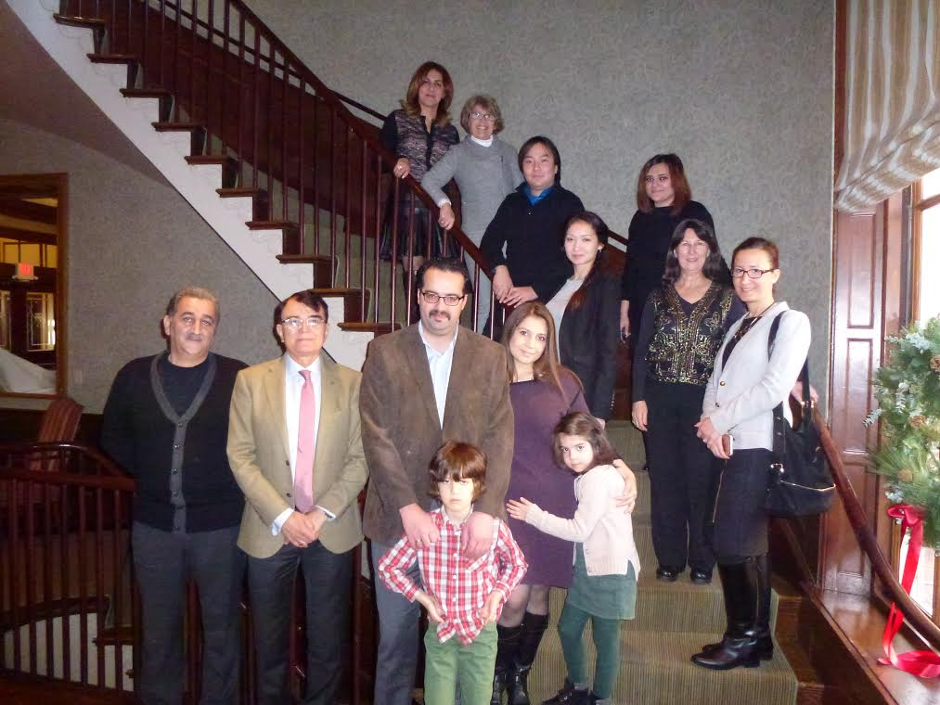
The first part I wanted to state is the program itself. The idea which lies behind of this program is the fact, that followers/participants should feel the spirit of being an USA citizen. We had to go deeply into the scientific society of Harvard University. The program coordinator wanted us not just to study but also, and more importantly, to be the part of this community. Therefore the period of staying was 5,5 month, which was the perfect timing. The program designed to help the researchers in their ongoing or future researches. We had professors and consultants, who were telling us and sharing with us their experience in scientific field. We’ve been taught how to settle the high quality research on basis of ethics. The ethics component of the program was crucial. Ethics is the main idea, that researcher should think of during the whole process of research, starting from literature review and ending with the final report or publication. And we’ve been helped not only by the staff of Fogarty program, but also Harvard University professors and Boston Children’s Hospital.
At Harvard University we had lectures just like any other students. We were treated with no difference compared to others, no discounts in grading and teaching. On the other hand the professors of Harvard School of Public Health (HSPH further on) were very interested in teaching us, because they never had that experience of teaching someone from Kazakhstan, and they wanted to know more and feel the difference in the ways of thinking between US students and Kazakhstan students. Basically it was a two way process, when I was providing some general information about our country, whereas they were giving me some basic ideas about the differences.
Talking about HSPH I cannot mention the history of this school. Harvard T.H. Chan School of Public Health traces its roots to public health activism at the beginning of the last century, a time of energetic social reform. The School began as the Harvard-MIT School of Health Officers, founded in 1913 as the first professional training program of public health in America. The partnership offered courses in preventive medicine at Harvard Medical School, sanitary engineering at Harvard University and allied subjects at MIT.
In 1922, the School split off from MIT, helped by a sizable grant from the Rockefeller Foundation. From the start, faculty were expected to commit themselves to research as well as teaching. In 1946, no longer affiliated with the medical school, the School became an independent, degree-granting body.
Many of the changes that unfolded in public health over the 20th century trace their origins to the School. Initially, researchers were preoccupied by deadly epidemic infections and by the scourges of unfettered industrialization. During the School’s first 50 years, the public health enterprise matured, drawing on a full range of analytic, scientific and policy disciplines. Today, the School’s purview extends from the genes to the globe. Its work encompasses not only the basic public health disciplines of biostatistics and epidemiology, environmental and occupational health, but also molecular biology, quantitative social sciences, policy and management, human rights, and health communications. Its leadership and outreach have informed public health practice around the world from decades of research in the People’s Republic of China to studies of health system reform in Taiwan and Poland, from collaborations on environmental health in Cyprus to intensive field training in Latin America.
In 2014, the Harvard School of Public Health was renamed the Harvard T.H. Chan School of Public Health in recognition of an extraordinary gift from The Morningside Foundation.
I was taking 4 courses at HSPH. Ethics of global health research is the course designed to expose us to the key ethical issues that may be encountered in the course of conducting global health research. Using case presentations and discussion-based class sessions, we had the opportunity to begin developing our own tools for dealing with these important issues in an applied context. During each class session, I, as a part of a group, presented case studies related to the topic covered in each session. The case study presentations should have been lasted approximately 15-20 minutes, allowing time for discussion afterwards. A double-spaced 3 - 4 page summary of the case discussion should have been written and handled over to the professor after the presentation; copies of any visual aids that are used should have been included. A single grade was awarded to all group members.
We were required to complete a “Write an Informed Consent Form” exercise, related to a fictional research proposal. I had to write a 15 - 20 page paper on a topic my choice. We were expected to meet with the instructor during the course to discuss potential topics. Grading was based on class participation (20%), the group presentation (25%), the Informed Consent exercise (15%), and the term paper (40%).
Responsible Conduct of Research is the course which meets the NIH training requirement for all trainees, fellows, participants, and scholars receiving support through any NIH training, career development award, research education grant, or dissertation research grant. It describes basic ethical and regulatory requirements for conducting research. We’ve been taught how to compare and contrast the concepts of research misconduct and research integrity, apply basic ethical and regulatory requirements for conducting bench, animal, clinical, and public health research, recognize when laboratory practices, publication practices, and other research practices deviate from legal, ethical, or regulatory requirements, and implement practices promoting compliance with ethical and legal requirements for the responsible conduct of research.

Introduction to the practice of Global Health. What is the definition of global health? What are its historic roots and modern manifestations? What are the major contemporary issues and debates on policies and practices? These questions were introduced in this introductory course that defined the scope of the field, highlighted contemporary issues, and reviewed selected case studies of global health policies and practices. An examination of world health and development stated the stage for subsequent sessions including: burden of disease; primary health care; the global fund for HIV/AIDS, malaria, and tuberculosis; the emergence of chronic diseases; the pharmaceutical industry; the role of NGOs and their impact on policy; and disaster management in an interconnected world. Case studies were used throughout course and were addressing critical elements in program implementation.

Evaluation Criteria. The following was required from each student:
Class Participation – We were expected to attend every class and participate regularly in class discussions. Student participation was implemented to show engagement with the material and relevancy of comments. (20% of final grade)
Advisory Memo - As a health consultant, we have been called on to advice the Minister of Health on what action to take following the announcement of a new research finding. We were given recent research articles, one of which should have been used as the basis for the memo. In a memo (no more than three single-spaced pages in length) to be given to the Minister of Health or his/her staff, we had to assess the soundness of the research and the real life implications that the findings might have. A plan should have also been presented to address policy and implementation with regard to the research findings. (30% of final grade)
Group Project Proposals and Presentations – We worked in small groups to develop a proposal for the implementation of a health intervention that would be addressed a specific issue of relevance to global health. (50% of final grade)
Individual and Social Responsibility for Health. The concept of responsibility for health plays a key role in health policy, but it is rarely articulated or evaluated. In this course, we were considered alternative understandings of assignments of responsibility for health to individuals, the state, the family, communities, nonprofit and for-profit firms, and other entities. We were identifying our occurrences in health policy debates, assessing the cogency of our use in ethical arguments in health policy, and trace the policy consequences of our normative analyses. The course also served as an introduction to ethical perspectives on public health.
The grade in this course was determined by performance in the following areas:
Class Participation
Learning in this class was chiefly accomplished through class discussion. Each student had to attend every class. We’ve been asked to pay very careful attention to the give-and-take during class, learning both from others’ insights and other’s errors. I did my best to enhance the learning of others with substantive contributions. I’ve also been told not to worry that my arguments could’ve been faulty; others would learn from my unsuccessful arguments as well as my good ones.
Students who found it difficult to speak up in class could meet the expectation of participation in other ways. Arrangements could be made individually with the instructor.
Mid-term and final exams (25% each)
Take-home mid-term and final exams tested our comprehension of readings, lectures, and class discussion. We could write up to five double-spaced pages, allocating space between questions as we liked.
Term Paper
Writing term papers of 6-8 double-spaced pages I could select any of several pre-approved topics from a list that was posted on the course website or might propose (by Nov. 17) a different topic of personal interest.
We were assigned a number of readings throughout this course. Some of these were closely-argued works by philosophers or economists that we might need to read more than once. Required readings should’ve been read carefully before class. Recommended readings offered additional critiques and additional approaches.
Now talking about Boston Children’s Hospital (BCH further on) I wanted to thank them for the opportunity for participating in the IRB (local ethical committee) meetings, while live cases were discussed. We’ve been asked to sign a document, in which we stated not to talk about the discussions itself and the topics, but I can say that with the help of this procedure I can now realize and understand how the whole process works.
Overall talking about the program I wanted to state the usefulness of the program. They gave us the idea of US thinking and solving the problems of research and ethics, the spirit of competitive society of researchers and the methods they use. I find personally the responsibility for implementing the ethics component into the local ethical committee and I will try to transfer the knowledge I received in USA into the Kazakh National Medical University society. We should try to implement the ideas used here and develop the KazNMU school of public health and ethical department into qualitatively new level.
In the end talking about Harvard University and USA as a whole I cannot leave unmentioned the Boston city, city of researchers and open minded students, where everybody can handle and realize the ideas they have in their minds, no matter how absurd they could be. They managed to create a society in the city, which supports everybody, who is brilliant in studying, developing and opening new horizons of thinking, reminds me the society of KazNMU, where every person/student can achieve this goals by just putting some effort into his dream.

