STUDENT SCIENTIFIC SOCIETY of
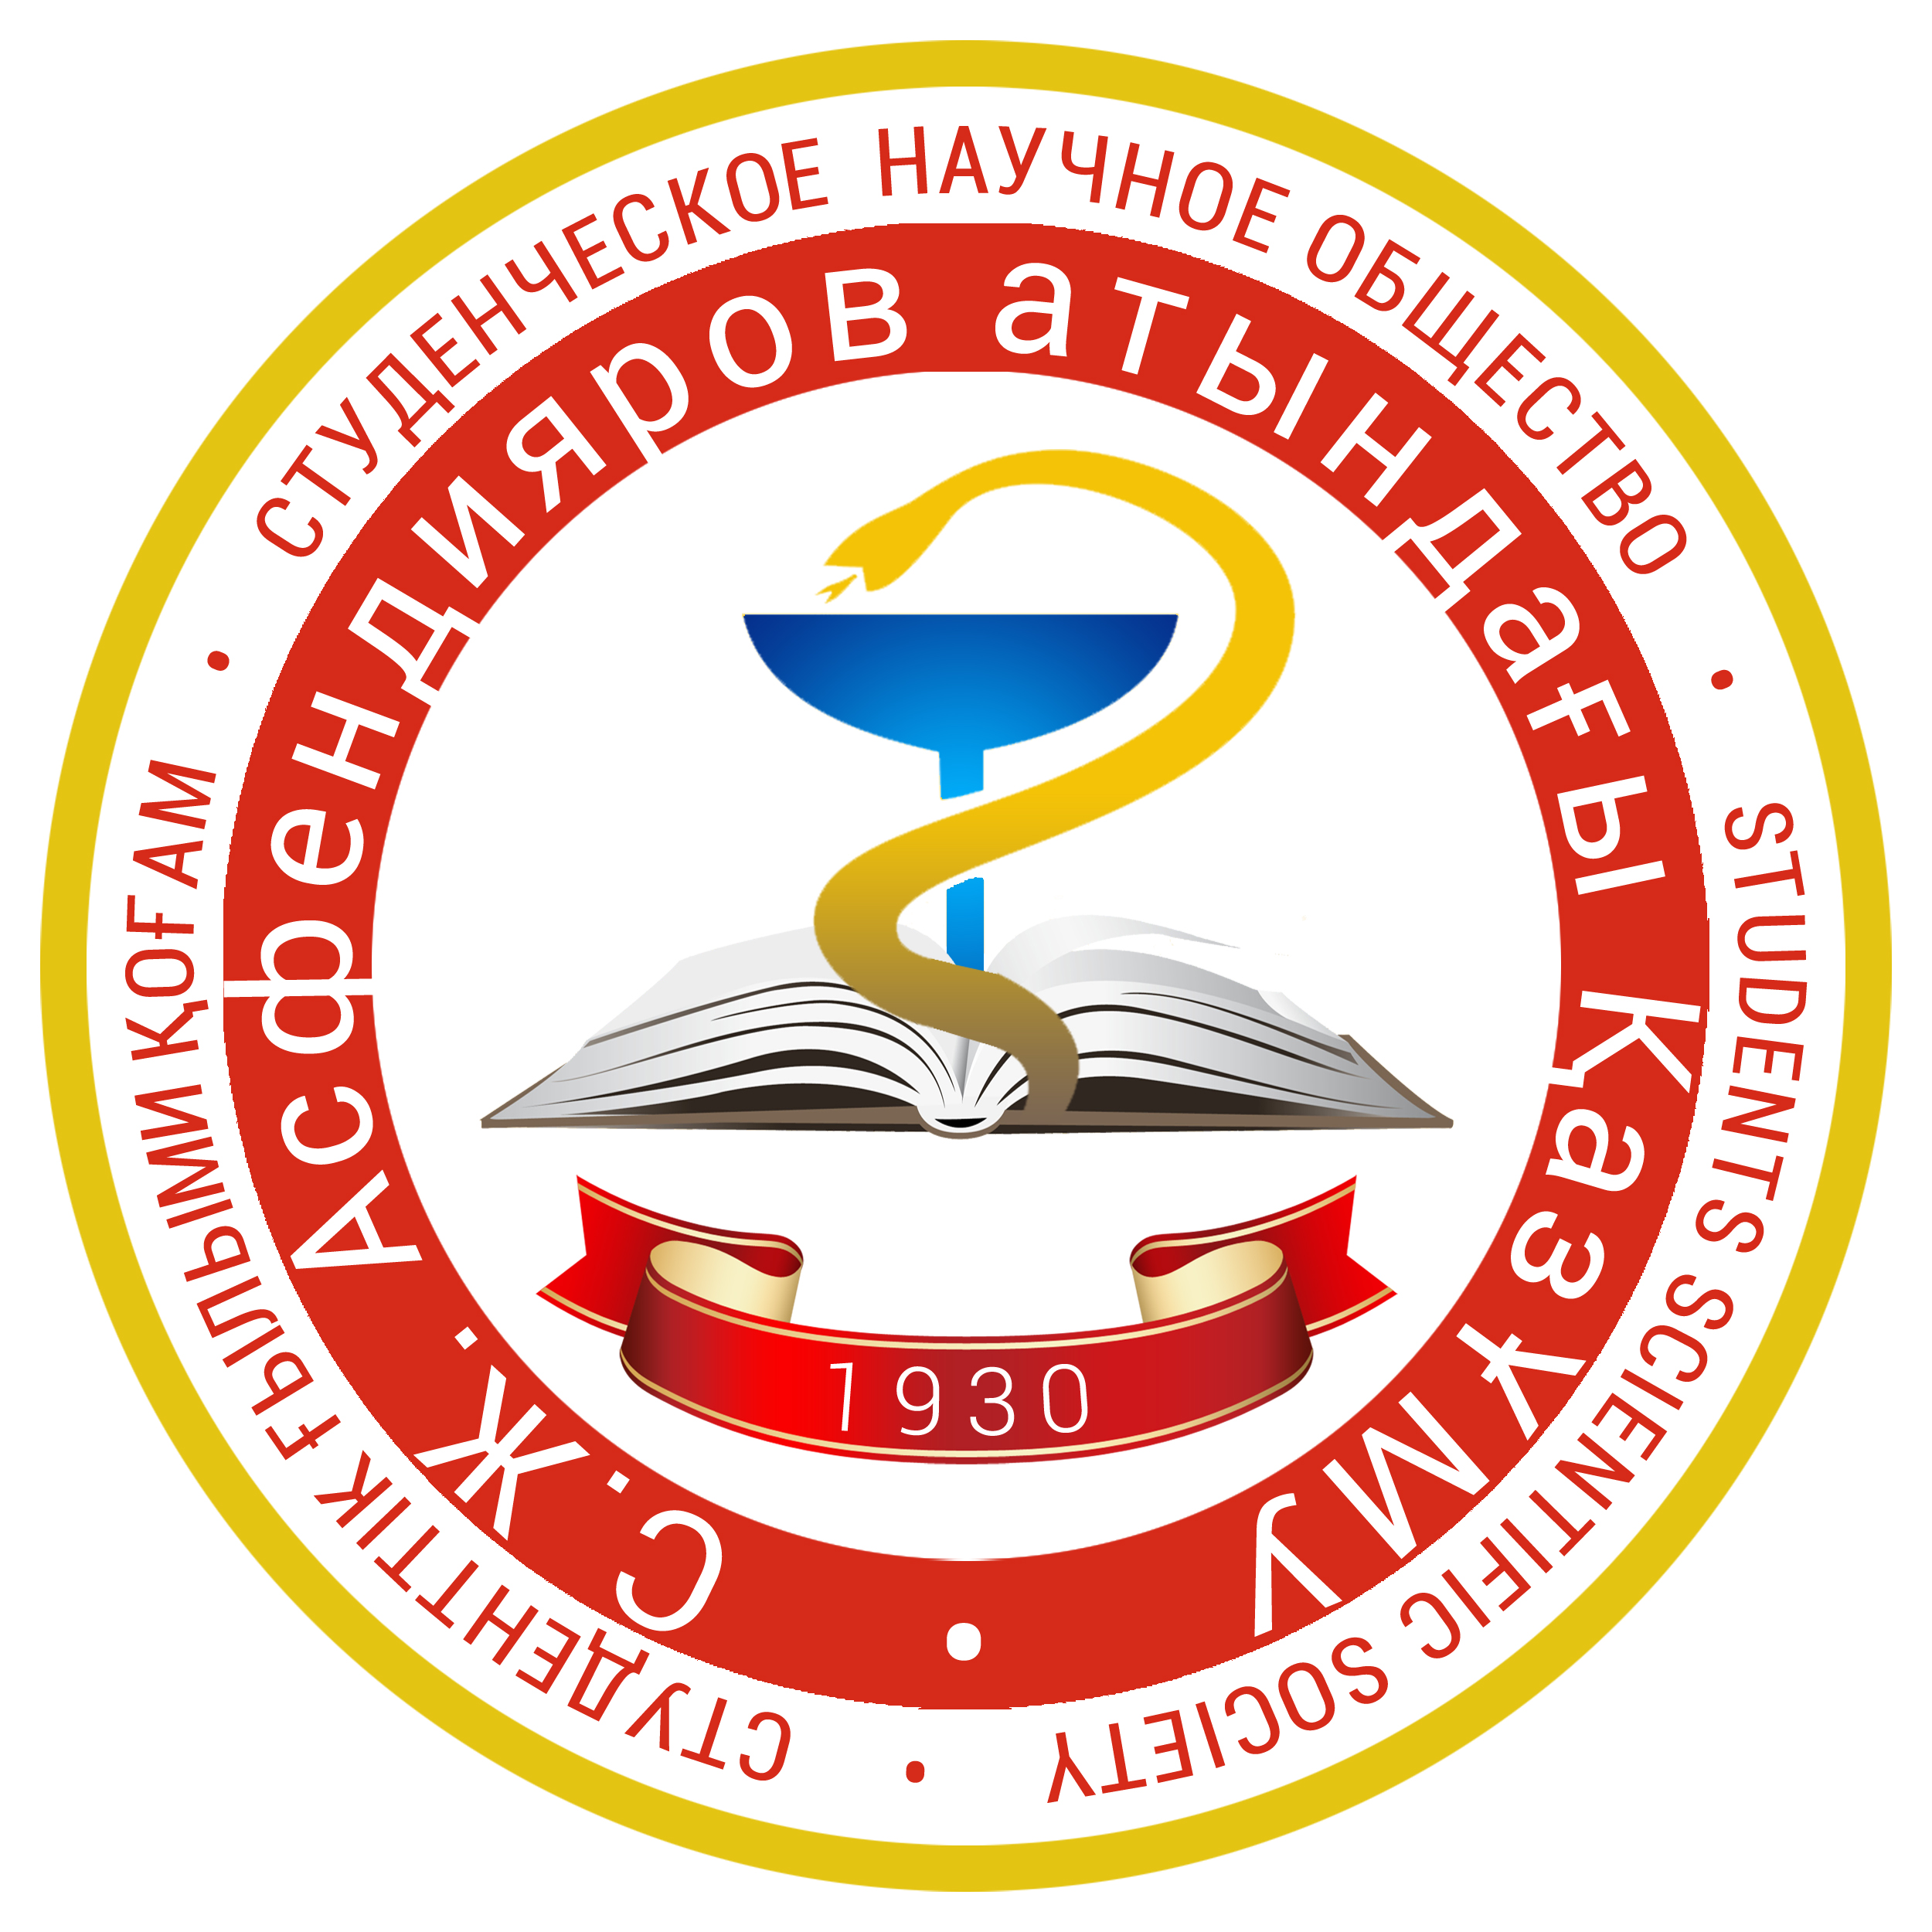ASFENDIYAROV KAZAKH NATIONAL MEDICAL UNIVERSITY

DEAR COLLEAGUES!

Student Scientific Society of Asfendiyarov Kazakh National Medical University invites you to take part in the IV International International Scientific and Practical Conference "Science and medicine: a modern view of youth", which will be held on 20-21 April 2017.

At the conference results of fundamental and clinical research should be presented. Deadline until March 25, 2017. Literary reviews will not be considered.
The purpose of the conference - the activation of scientific activities of students and young scientists, the expansion of their scientific outlook and links between different research areas, the exchange of relevant information, the identification and development of innovative potential of young people.
Conference papers will be published in a special publication of «International Student's Journal of Medicine». The electronic version of the journal articles will be available at: kaznmu.kz, vk.com/snokaznmu
Participation in the conference and the publication are free of charge. Travel expenses and meals should be covered by the sending side. It is possible to provide centralized accommodation in hostel; information regarding prices could be got from organizational side.

Conference languages: Kazakh, Russian, and English.
The participation form:
1. Oral presentation and abstract publication
2. Poster presentation and abstract publication
3. Only abstract publication
Attention!
Participants of the correspondence form will not able to receive the certificate of participation in the conference.

The main scientific directions of the Conference:
1. Internal Medicine mnpk2017vb@mail.ru
2. Surgical diseases, anesthesiology, and resuscitation mnpk2017hb@mail.ru
3. Pharmacy and Pharmacology mnpk2017ph@mail.ru
4. Dentistry mnpk2017st@mail.ru
5. Obstetrics and Gynecology mnpk2017ag@mail.ru
6. Pediatrics and Neonatology mnpk2017pn@mail.ru
7. Morphological Discipline mnpk2017mo@mail.ru
8. Public health and health care mnpk2017oz@mail.ru
9. Fundamental discipline mnpk2017fd@mail.ru
10. Immunology, Infectious diseases, epidemiology mnpk2017ib@mail.ru
11. Neurology, Psychiatry, and Narcology mnpk2017np@mail.ru
12. Health and Environment mnpk2017ge@mail.ru
13. Poster section mnpk2017ps@mail.ru

During the preparation for the conference, according to the number of applications and wishes of the participants, there is the possibility to correct planned sections.
The Organizing Committee will select only the applications of original research projects. Reviews will not be considered. The duration of oral presentation - 5 minutes.
Requirements for poster presentation are listed in Appendix №3. Production of poster-report is carried out at the expense of the author.
Requirements for participatation in the conference:
- Formalize and submit thesis in accordance with the requirements (see. Appendix №1, №2) and send to appropriate e-mail.
- Send the scanned version of the thesis (in jpg or pdf format) with signatures of all authors and visa "for print" of the head of the department to e-mail of the Organizing Committee.
- Fill the application form for participation in the conference (see Appendix 4) and send to appropriate e-mail.
- All three documents (thesis in Word format, scanned version of the thesis, and application) have to be sent once by one message.
Upon receipt of materials Organizing Committee will send senders an invitation and will provide additional information on participation in the conference in three days from the date of submission.

Submissions will be accepted until March 25, 2017.
Thesis, which does not meet the requirements AND SENT LATER THAN 03.25.2017, will not be accepted for consideration.

PRELIMINARY CONFERENCE PROGRAM

APRIL 19, 2017 - Arrival of participants, transfer from station, airport to hotel and hostel of KazNMU.
1-ST DAY, APRIL 20, 2017
A summary of the first day: the day is dedicated to the opening of the conference, plenary sessions, workshops, and tours in the city.
Time | Event | Description of the event | Venue
9.00-9.30 | Registration | Registration for the conference | Conference Hall of University's Theatre «Concordia»
9.30-10.30 | Opening | Greetings:  1) The Rector of Asfendiyarov Kazakh National Medical University,  2) The Vice-Rector for Research and Innovations  3) The Director of Atchabarov Research Institute  4) The Chairman of Student Scientific Society of Asfendiyarov Kazakh National Medical University, | Conference Hall of University's Theatre «Concordia»
10.30-12.00 | Plenary session №1 | Lectures of Visiting Professors | Conference Hall of University's Theatre «Concordia»
12.00-13.00 | Lunch break |  | KazNMU Student's Cafeteria
13.00-15.00 | Workshops | Workshops by choice | Kozhakanov Center of practical skills
15.00-17.00 | City tour | Excursion to the main attractions of the city of Almaty | Almaty city

2-ND DAY, APRIL 21, 2017
A summary of the second day: the day is dedicated to breakout sessions on main research areas.
Time | Event | Description of the event | Venue
9.00-10.00 | Registration | Registration for breakout sessions | KazNMU Classrooms
10.00-13.00 | Breakout sessions | Breakout sessions on main research areas | KazNMU Classrooms
13.00-14.00 | Lunch break |  | KazNMU Student's Cafeteria
14.00-15.00 | Plenary session №2 | Award winners. Closing of the conference. | KazNMU Hall of Fame

APRIL 22, 2017
Departure of the participants, transfer from hotel and hostel of KazNMU to station, airport.
Contacts of the organizing committee:
- Organizing group of scientific events, the Student Scientific Society, and the Council of Young Scientists. The main Specialist: Nuralina Marzhan Embergenovna. Specialist: Mukhamedzhanova Zhadyra Mauletovna. Phone: +7 727 338 7090, +7 775 762 6133
E-mail: nirs@kaznmu.kz
- Student Scientific Society of Asfendiyarov Kazakh National Medical University. The Chairman: Abilkhas Asylzhan Akimkhanuly. Phone: +7 771 390 9408
E-mail: abilkhas.asylzhan@gmail.com.
- Conference organizing committee leader: Toktakhan Nazerke Zekenkyzy
Phone: +7 701 481 8825 Email: nazeka.m@mail.ru
- Full information is available at: www.kaznmu.kz, nirs.kaznmu.kz, vk.com/snokaznmu.

APPENDIX №1
Requirements for abstracts *
- Abstract volume–no more than 1 page (2500 symbols (including spaces).
- The abstract have to be printed on typewritten sheets of A4 (1 copy), the font TimesNewRoman, font size - 12, interval - 1, paragraph - 5 mm. Fields: left - 20 mm, right - 20 mm, the upper - 20 mm, bottom - 20 mm.
- Structure of the thesis: the article title in capital letters (centered, bold) below - in italics - the author (co-authors) (name, course, faculty, university name, city, country); below in italics - the supervisor (degree, title, name); below in italics - Department. After an interval - the text of the abstract. After the text of the abstract in one interval - References (no more than 5 sources). Sources are arranged in alphabetical order. The structure of a bibliographic reference to the article - Author, AA, Author, BB, Author, CC (year). Title of the article. Journal title, volume, number, page structure of bibliographic references on books - Author, AA, Author, BB, Author, CC (year). The book's title. Publisher, City, Volume, p. In the text should indicate the reference number in square brackets figures.
- The main text of the abstract should include: date (brief description of the relevance of the test questions); The purpose and objectives (solution which allows to achieve the target); Materials and methods (description of the research methodology); Results and Discussion (interpretation of results). Conclusions.
- While using the results of the statistical analysis of the data, it is obliged to indicate a software package and its version, the names of statistical methods to bring descriptive statistical methods and exact significance levels when testing statistical hypotheses. For the main results of the study confidence the using of intervals are recommended.
- The use of tables, graphs, diagrams, illustrations in the text of the abstract is not allowed.
- The editors reserve the right to edit materials of the abstract. Minor stylistic or formal, nomenclatural corrections are included in the abstract without the consent of the author.

*Note: Abstract should be formalized in a separate document MicrosoftWord, in the file name indicate the participant's name and type of document(e.g. Ivanov – abstract.doc). Example of abstract– Appendix №5.

APPENDIX №2
ABSTRACT EXAMPLE
FEATURES OF ECG INDEX IN SPORTS
D. A. Ivanov, the fifth grade, faculty of «General Medicine »
Kazakh National Medical University named after S .D. Asfendiyarov
Almaty, Republic of Kazakhstan
Supervisor: Doctor of Medical Sciences, professor A. A. Omarov
Department of Normal Physiology

ABSTRACT TEXT ABSTRACT TEXT ABSTRACT TEXT ABSTRACT TEXT
ABSTRACT TEXT ABSTRACT TEXT ABSTRACT TEXT ABSTRACT TEXT
ABSTRACT TEXT ABSTRACT TEXT ABSTRACT TEXT ABSTRACT TEXT

REFERENCES:
- Author, AA, Author, BB, Author, CC (year). Title of the article. Journal title, volume, issue, pages.
- Author, AA, Author, BB, Author, CC (year). The book's title. Publisher, City, volume, pages.
- Author, AA, Author, BB, Author, CC (year). Title of the article. Journal title, volume, issue, pages.

APPENDIX №3
REQUIREMENTS FOR POSTER PAPERS (STAND):
- At the top of the poster the name of the work (capital letters, without isolation, no more than three lines), authors (name, course, faculty, university name, city, country), the supervisor (name, title, degree, department, name of the university, city, country)should be indicated.
- Posters (stand) should contain materials of scientific research: the purpose of research, methods and methodology of the study, a brief summary of the practical part, results in the form of graphics, tables, diagrams, illustrations, charts, drawings (the amount of which shall not exceed the size of A4 paper).
- The size of the stand: height - 90 cm, width - 130 cm.
- The size of the font should be readable at a distance of 100cm.

APPENDIX №4
HOW TO FILL IN THE APPLICATION
Participant name (in full) | Ivanov Dmitry Alekseevich
Position (student / young scientist) | Student
Date of birth and age (DD / MM / YY and NN years) | 14.12.92-22 years old
Gender (male / female) | Male
Class, faculty (for students); Position (for young scientists) | Fifth grade, Faculty of «General Medicine»
Title of scientific research | Features of ECG index in sports
Name, academic degree and title of the supervisor | A. A. Omarov Doctor of Medical Sciences,  Professor
Department | Department of Normal Physiology
University (full name), city and country | Kazakh National Medical University named  after S. D. Asfendiyarov, Almaty, Republic of  Kazakhstan
The form of participation:  1) Oral report and publication of abstract  2) Poster presentations and publication of the thesis  3) Only publication of abstract | Oral report and publication of abstract
Section:  1) Internal Diseases  2)Surgical diseases, anesthesiology, and resuscitation  3) Pediatrics and Neonatology  4) Pharmacy and Pharmacology  5) Dentistry  6) Obstetrics and Gynecology  7) Neurology, Psychiatry and narcology  8) Hygiene and Ecology  9) Morphological sciences  10) Public Health  11) Research in Nursing  12) Radiological diagnosis and treatment, oncology  13) Fundamental sciences  14) Immunology, Infectious diseases and epidemiology | Morphological sciences
Performance language (Kazakh / Russian / English) | Russian
E-mail: | Ivanov@yandex.ru
Contact phone for rapid communication: | +7 777 787 5555
The need to book a room in the dormitory of KazNMU (Yes / No) | Yes

